Operating System [Unit 3]
Lab 3
Deadline: 2081-04-32
- Implementation of Semaphores for process synchronization.
- Implementation on Banker’s algorithm for multiple instances for multiple resource types.
- Implementation of deadlock avoidance with single resource with multiple instances.
Assignment 3
Deadline: 2081-05-05

- What is deadlock? Explain various conditions for deadlock.
- Discuss Banker’s Algorithm with multiple resource for avoidance of deadlock.
- Suppose three peoples are in line waiting for a department store to open for "the big sale". When the door opens, all three rush the door, but the door is not big enough for all them to pass through at once. Describe a solution for addressing this deadlock that will allow three peoples to pass through the door. Which of the 4 necessary deadlock conditions does your solution break? Explain.
- Difference between deadlock and starvation.
- How unsafe state differs from deadlock state. Find the safe state here:
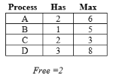
- What is resource allocation graph? What do you understand by deadlock detection and avoidances?
- Discuss about deadlock recovery.
- A system has two processes and three identical resources. Each process needs a maximum of two resources. Is deadlock possible? Explain your answer.
- Why does deadlock occur? What do you mean by aging?
- Compute.
  - Find safe state.
  - If a request from process from P1 arrives for (0, 4, 2, 0), can the request be granted immediately?
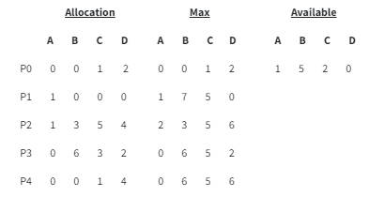
- Explain Semaphores and Mutex. Does these affect the process to be deadlocked?

